Practical No. 3

Name : Danish Altaf Solkar Class : CO - B
Enrolment no. : 24111590805 Batch : 2

Aim : a) Commands for sending message to logged-in users who, cat, wall, write, mesg.

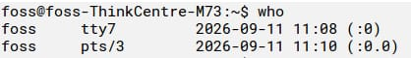

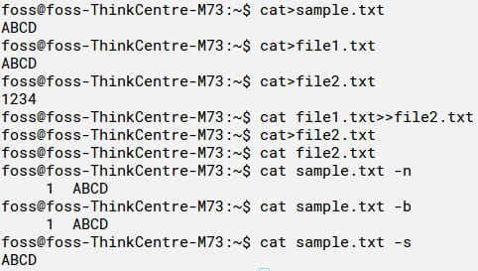

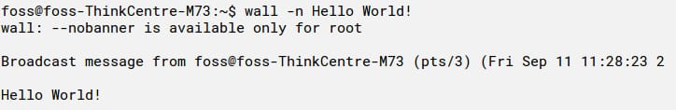

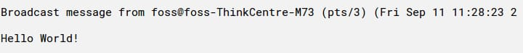

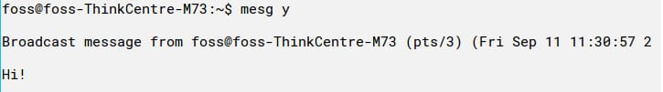

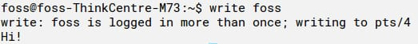

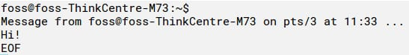

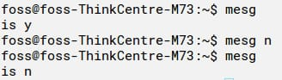

Aim : b) List Processes attached to a shared memory segment : ipcs

